OPTIMIZATION OF OPERATIONS AND REVENUE AT PLATT LAUNDROMAT

Nigel Faulkens

Juhyun Lee

Neelay Patel

Shayaan Siddiqui

Department of Industrial and Operations Engineering

1205 Beal Avenue

University of Michigan

Ann Arbor, MI 48109-2117

**ABSTRACT**

Platt Laundromat is a popular laundry facility located between Ann Arbor and Ypsilanti, Michigan. Due to its importance to the surrounding community, the owners of Platt Laundromat are always looking for ways to remove shortcomings in their operations in order to optimize revenue and customer satisfaction. This paper discusses our analysis of weekly operations at Platt Laundromat using the simulation package ProModel. After developing a simulation model using data obtained from informal time studies that we conducted at the facility, we collected data regarding customer wait times, machine utilization, and revenue on each day of a given week in the laundromat’s operation. We also utilized SimRunner, ProModel’s optimization testing feature, to determine optimal incentives to try to attract more customers on weekdays, as the facility experiences high volumes on weekends and the owners would like to find ways to distribute customer traffic out more evenly throughout the week. We determined that discounting washer prices by $1 and dryer prices by $0.50 on weekdays (Monday through Friday) would increase the arrival frequency on those days while maintaining or even increasing revenue. From our results, we concluded that Platt Laundromat should utilize a $1.00 off weekday special.

# INTRODUCTION

Platt Laundromat is a multi-functional laundry facility located in Ann Arbor, Michigan. The facility’s washing machines and dryers have self-serve capabilities, but Platt also offers their own Wash & Fold Service for an additional fee. There are also laundry products available for purchase at the facility. Laundromats serve an important role in communities, as not everybody has the financial or logistical access to an in-unit washer/dryer and need to seek out other means in order to have clean clothes to wear. They are known to have complex yet intuitive systems and processes, and depending on the time of day and day of the week, can either be a trouble-free trip or a big pain for customers.

**1.1 System Description**

The process of the laundry service begins with customers arriving at the laundromat, then moving to the waiting area or the front desk line, depending on their desired service. Customers who brought their own detergent for self-serve laundry find an open washing machine matching their load size and begin. Otherwise, customers line up at the front desk to buy detergent or pay for the Wash & Fold. Wash & Fold patrons exit the facility after paying while detergent buyers move to the waiting area. In the waiting area, if all the washers of the respective load size are occupied, customers remain in the waiting area until one opens, or they decide to exit the laundromat if the wait is too long. Once a load is done in the washing machine, the customer moves it to the dryer. After the load has finished in the dryer, customers exit the laundromat or purchase a snack or drink at the vending machine before exiting. A ProModel layout of this system is shown in Figure 1.

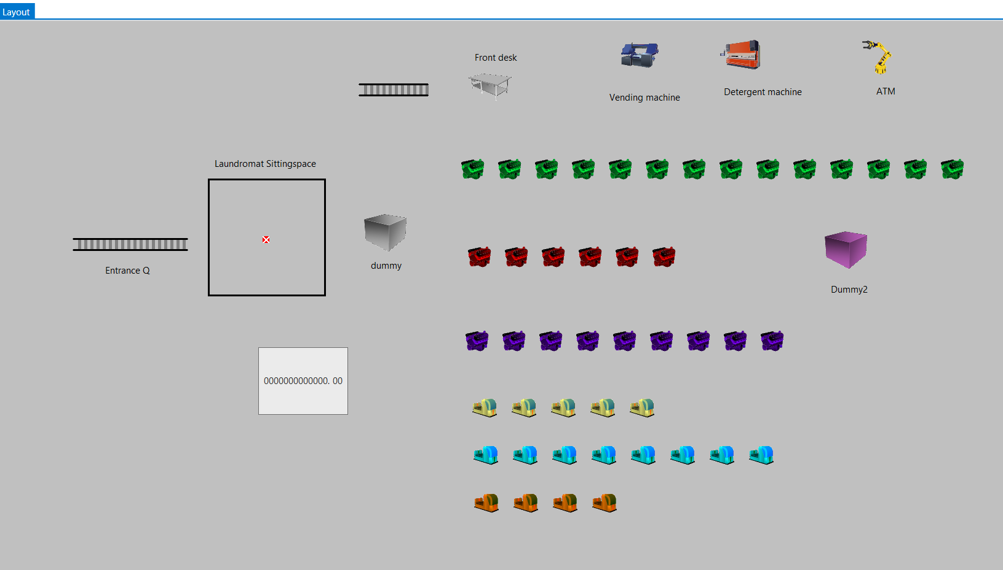

Figure 1: Layout of the System in ProModel.

**1.2 Problem Description**

Due to the popularity of the Monday-Friday work schedule, most customers do their laundry on the weekends. Consequently, Platt Laundromat’s customer traffic is concentrated heavily on Saturday and Sunday, leading to long wait times and the potential for lost sales. In this paper, our team looks to prevent customer congestion and loss of business by distributing customer traffic more evenly throughout the week. We focus on special deals that would encourage customers to do their laundry during the week.

**1.3 Importance**

Reducing customer traffic congestion will reduce wait times and thereby total time customers spend at Platt Laundromat. This will save customers valuable time, and will also reduce pressure on the laundromat staff.

# METHODS

## Assumptions

As is the case with many commercial facilities and their processes, assumptions had to be made in order to accurately collect and analyze the data within the constraints of ProModel. The laundromat has seats where customers can sit and wait, but also room throughout the facility where customers can stand and wait. To account for this, we will assume that there is a singular waiting area with a capacity of 30 people, which is roughly the combined amount of people that can sit and stand. When we met with the laundromat owner, he explained to us that people usually don’t have to wait too long, but there is about a 5% chance that they have to wait for >10 minutes. We will assume this is the threshold for excessive waiting time, causing the customer to leave the facility in the case that they have to wait that long.

The laundromat owner also informed us that there are 29 total washers of five different sizes (2, 3, 4, 6, and 9 loads), and 17 total dryers of three different sizes (3, 5, and 8 loads). To streamline a customer’s washer and dryer preference, we will assume there are three types of each: small, medium, and large, and which types a customer chooses depends on the size of the laundry load that they walk into the facility with. The grouping of washers and dryers into the three categories is shown in Table 1.

Table 1: The grouping of the different sizes of washers and dryers into the three streamlined categories (small, medium and large).

| **Size of Load** | **Machines Used** |
| --- | --- |
| Small | 2 or 3 load washers  3 load dryers |
| Medium | 4 load washers  5 load dryers |
| Large | 6 or 9 load washers  8 load dryers |

Table 2: Pricing and operation times for washers and dryers at Platt Laundromat.

| **Type of Machine** | **Length of Operation** | **Price** |
| --- | --- | --- |
| Washer | 25 minutes (all) | $3.50 (2 loads)  $5 (3 loads)  $6.25 (4 loads)  $8.75 (6 loads)  $11 (9 loads) |
| Dryer | $0.25 per 7 minutes (3 loads)  $0.25 per 5 minutes (5 loads)  $0.25 per 4 minutes (8 loads) | |

Table 2 shows the pricing and operation times for different sized washers and dryers in the facility. Using our assumption of three categories, we will assume a small washer price of $4.25 (average of $3.50 and $5), a medium washer price of $6.25, and a large washer price of $9.85. According to the owner, on average, the 3 load dryers take 35 minutes, the 5 load dryers take 40 minutes, and the 8 load dryers take 44 minutes. Based on this information and the dryer pricing system shown in Table 2, we will assume a small dryer price of $1.25, a medium dryer price of $2.00, and a large dryer price of $2.75. Additionally, we will assume that since dryer operation times are random, they will follow a triangular distribution. This is shown for the three dryer categories in Table 3. The minimums and maximums were given by the laundromat owner.

Table 3: Triangularly distributed operation times for the three categories of dryers.

| **Size of Dryer** | **Operation Time** |
| --- | --- |
| Small | T(33, 35, 37) |
| Medium | T(37, 40, 43) |
| Large | T(40 ,44, 48) |

Some other assumptions we made involved the additional machines and services provided by Platt Laundromat. One of these is a Wash & Fold Service where customers can bring their laundry to the front desk and Platt’s staff will complete it for them. The laundromat charges $2 per pound of laundry for this service, with fixed costs for blankets ($20 for throw and twin, $25 for king and queen). To simplify this process in our model, we designated it as a singular operation at the front desk location that costs $10, which was given to us as an average load amount by the laundromat owner. Platt Laundromat also sells various laundry products for $6 at the front desk, so we will assume that the average customer would spend $6 if they were purchasing these products.

The laundromat also has a machine that sells single-use laundry products for $1 each, and we will assume that the average customer would purchase two of these, so we set a price of $2 at this machine. Also, the facility has a vending machine where snacks and drinks are sold. After looking at everything sold and their respective prices, we will assume a price of $1.50 for any customer that uses this machine.

## Data Collection

The team collected data at Platt Laundromat on three different days of the week: a Tuesday, a Thursday, and a Sunday, for a four-hour window (2 pm - 6 pm) on each day. The reason this was done is because the week varies in customer traffic; Monday through Wednesday tend to be the slowest, Thursday is an intermediate, and Friday through Sunday are the busiest, especially Sunday. The data collected included interarrival times, the probability of customers that came in with a small, medium, or large load (based on which machines they used), and the probability of customers using the additional machines and services provided by Platt Laundromat. We believe that the time window we chose is a fairly common time to go to the laundromat, so we believe this ensured the accuracy of our collected data.

**2.2.1 Preliminary Data**

The exact times that each customer arrived at the laundromat were documented throughout the four-hour period on all three days of data collection, and the team formulated the weekly distribution for interarrival times shown in Table 4. It is worth noting that due to the long operating hours of the facility (13.5 hours every day) and time constraints of team members’ busy schedules, we felt that we weren’t able to capture the full daily interarrival time distribution, so we assumed an exponential distribution. Additionally, since we were only able to collect data on three days of the week, we used the information the laundromat owner gave us about arrival frequencies to estimate the interarrival times for the other four days.

Table 4: The interarrival times at Platt Laundromat for each day of the week.

| **Day of the Week** | **Interarrival time (min)** |
| --- | --- |
| Monday-Wednesday | E(13) |
| Thursday | E(10) |
| Friday | E(7) |
| Saturday | E(6) |
| Sunday | E(5) |

Table 5 shows the probabilities that a customer came in with a small-, medium-, or large-sized load. We determined this by tallying which machines customers used, as the owner informed us which washers and dryers are small, medium, and large.

Table 5: The probability distribution of what size load customers arrived at the laundromat with..

| **Size of Load** | **Probability** |
| --- | --- |
| Small | 0.3 |
| Medium | 0.5 |
| Large | 0.2 |

Table 6 shows the probabilities that a customer used the additional machines and services provided by the laundromat. We determined this by standing near the front desk and tallying how many customers came to the desk, and how many were there for a given machine or service.

Table 6: The probability distribution of utilization of additional machines and services by customers.

| **Service** | **Probability** |
| --- | --- |
| Wash & Fold | 0.1 |
| Products sold at front desk | 0.2 |
| Single-use products sold at machine | 0.2 |
| Vending machine | 0.25 |

Finally, the owner informed us that ⅓ of the machines in the facility have card readers that don’t work, and if a customer ends up at one of these machines, they usually have to go to the ATM within the laundromat to get quarters. We timed how long it took for customers to do this, and found that it added a delay of 5 minutes to their washing or drying time. This will also be incorporated into our model, and we will assume that the delay is exponentially distributed to account for stochasticity.

## Model Description

The simulation model of Platt Laundromat was created in ProModel with the following descriptions. The model simulated Platt Laundromat for 13.5 hours (length of business hours) on each day of one week, with each weekday’s respective interarrival times taken into account.

**2.3.1 Locations**

The locations used in the model are defined below:

* Physical Locations
  + *Laundromat_Sittingspace* - The waiting area of the laundromat; there is a capacity of 30
  + *Washer_Small* - The small-sized washers; there are 9 of them
  + *Washer_Medium* - The medium-sized washers; there are 14 of them
  + *Washer_Large* - The large-sized washers; there are 6 of them
  + *Dryer_small* - The small-sized dryers; there are 5 of them
  + *Dryer_medium* - The medium-sized dryers; there are 8 of them
  + *Dryer_large* - The large-sized dryers; there are 4 of them
  + *Front_desk* - The front desk where customers go for additional services and products
  + *Vending_machine* - The vending machine where customers can purchase snacks and drinks
  + *Detergent_machine* - The machine where customers can purchase single-use laundry products; for simplicity, customers aren’t actually routed to this location, but it is there for the purpose of replicating the setup of the facility
  + *ATM* - Where customers can get quarters if they end up at a laundry machine with a broken card reader; for simplicity, customers aren’t actually routed to this location, but it is there for the purpose of replicating the setup of the facility
* Dummy Locations
  + *dummy* - A dummy location that serves as a decision node to route customers to a specific size of washers depending on the size of their load, which is randomly assigned by a user distribution
  + *Dummy2* - A dummy location that serves the same purpose as ‘dummy,’ but it is used to route customers to a specific size of dryers once they are done washing their clothes; the same user distribution for load size is used to streamline the process
* Queues
  + *Entrance_Q* - Where the customers arrive and wait to sit in the waiting area or go wait in line at the front desk
  + *frontdesk_Queue* - Where the customers who have front desk-related needs wait in line

All physical locations have a capacity of one customer, with the exception of the waiting area, which has a capacity of 30 customers. All queues have an infinite capacity.

**2.3.2 Entities**

The entity used in the model is defined below:

* *customer* - Arrive to the entrance queue at a frequency based on what day of the week it is

**2.3.3 Attributes**

The attributes used in the model are defined below:

* *customertype* - Based on a user distribution to assign if a customer will end up waiting >10 minutes and leave or not
* *loadType* - Based on a user distribution to assign what size load a customer will arrive with
* *ReaderType* - Based on a user distribution to assign if a customer will encounter machines with a broken card reader or not
* *FrontDeskType* - Based on a user distribution to assign what type of front desk-related service a customer who goes to the front desk will need

**2.3.4 Global Variables**

The global variables used in the model are defined below:

* *revenue* - Total revenue accumulated in a day; incremented when a customer pays for a laundry machine, or purchases a product or service at the front desk/vending machine
* *Customers_Lost* - Total number of customers that left because they had to wait >10 minutes; incremented when a customer leaves the waiting area

**2.3.5 Processes**

Figure 2 shows a high level process flow diagram of the model:

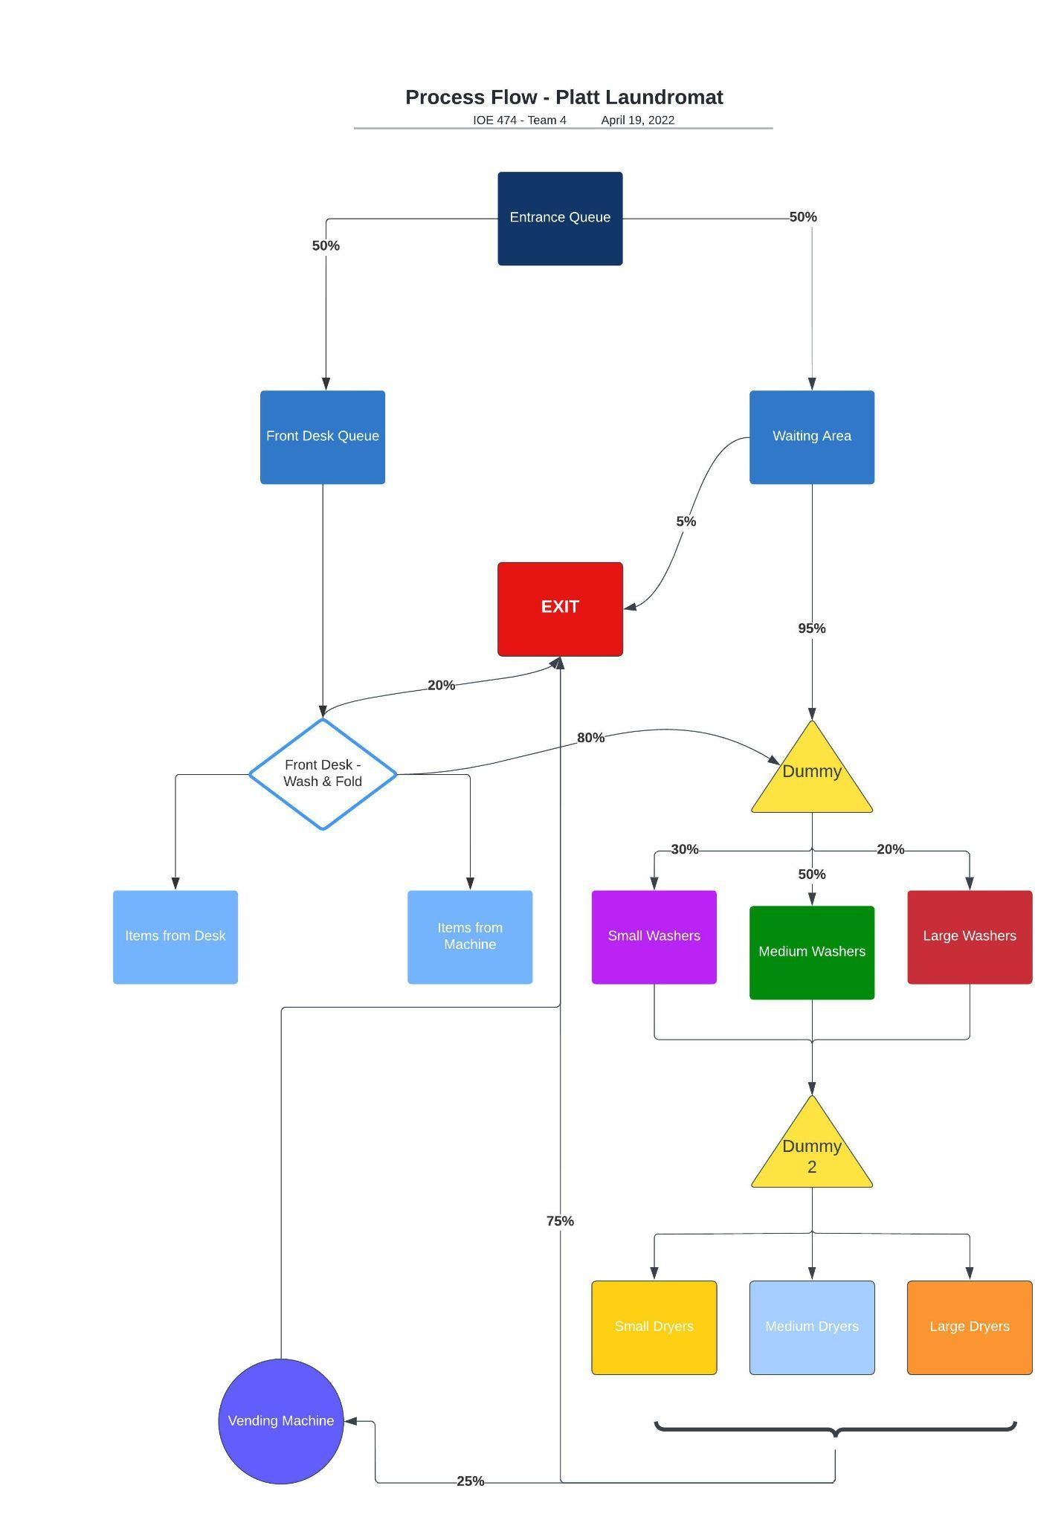

Figure 2: Platt Laundromat Process Flow Diagram

**2.3.6 User Distributions**

The user distributions used in the model are defined below:

* *Customer_Type* - a user distribution to assign if a customer will end up waiting >10 minutes and leave or not; assigned to the *customertype* attribute
* *Load_type* - a user distribution to assign what size load a customer will arrive with; assigned to the *loadType* attribute
* *Reader_Type* - a user distribution to assign if a customer will encounter machines with a broken card reader or not; assigned to the *ReaderType* attribute
* *FrontDesk_Type* - a user distribution to assign what type of front desk-related service a customer who goes to the front desk will need; assigned to the *FrontDeskType* attribute

**2.3.7 Macros**

The macros used in the model are defined below:

* *ArrivalFrequency* - a macro used to change the interarrival time based on the day of the week
  + Ranging from 5 to 13 minutes
  + Used in Arrivals as arrival frequency
* *SmallWasherPrice* - a macro used to change the price of small washers, as the laundromat is experimenting with discounts on weekdays
  + Ranging from $1.75 to $4.25
  + Used in Processing at *Washer_Small*
* *MediumWasherPrice* - a macro used to change the price of medium washers, as the laundromat is experimenting with discounts on weekdays
  + Ranging from $3.75 to $6.25
  + Used in Processing at *Washer_Medium*
* *LargeWasherPrice* - a macro used to change the price of large washers, as the laundromat is experimenting with discounts on weekdays
  + Ranging from $7.35 to $9.85
  + Used in Processing at *Washer_Large*
* *SmallDryerPrice* - a macro used to change the price of small dryers, as the laundromat is experimenting with discounts on weekdays
  + Ranging from $0.25 to $1.25
  + Used in Processing at *Dryer_small*
* *MediumDryerPrice* - a macro used to change the price of medium dryers, as the laundromat is experimenting with discounts on weekdays
  + Ranging from $1.00 to $2.00
  + Used in Processing at *Dryer_medium*
* *LargeDryerPrice* - a macro used to change the price of large dryers, as the laundromat is experimenting with discounts on weekdays
  + Ranging from $1.75 to $2.75
  + Used in Processing at *Dryer_large*

# RESULTS

Once the team ran the ProModel simulation, results for each weekday scenario were gathered and compared. The output analysis is shown in section 3.3. We also ran an optimization exercise through ProModel’s built-in optimization software, SimRunner, regarding the optimal discounts to offer customers to incentivize greater customer traffic on the weekdays and relieve staffing pressures on weekends, while also maintaining revenues. The results of the optimization and analysis are shown in section 3.4.

## Model Verification

After the model was completed, the two members of the team who did not develop the simulation looked through every part of the model. This gave us the opportunity to verify that the code met the model specifications that are laid out in section 2. We also used the animation feature of ProModel to ensure that the entities were smoothly moving through the simulation in a manner that made sense. It was important to do this because Platt Laundromat has many moving pieces, and we suspected that the variability in the routing across the model might cause entities to get stuck, but fortunately, this was not the case and the model ran as it was coded to run.

## Model Validation

The model was validated using face and data validation. Every aspect of the model was closely observed and compared to the preliminary data we collected from Platt Landromat. The animation feature of ProModel was utilized for this as well; we slowed down the speed of the simulation and were able to compare the waiting area, the utilization of washers and dryers, and the amount of customers using the additional services and machines to what we had seen in the real system. We also used the output data generated by ProModel to validate the model. By comparing the utilizations of all the different locations, machines, and services within the laundromat, as well as the length of the front desk queue and amount of lost customers, we were able to confirm that the model accurately captures a customer’s movement from the moment they arrive at the laundromat to the moment they leave.

* 1. **Output Analysis**

After running the simulation for each day of a given week, the team accumulated the results. Table 7 shows the greatest individual machine utilization for both washers and dryers (as well as what category the machine belonged to) and the number of customers lost for each day of the week.

Table 7: The utilizations of the most-commonly used washers and dryers, as well as their category, and the number of customers lost for each day of the week.

| **Day of the Week** | **Greatest Washer %Utilization** | **Greatest Dryer %Utilization** | **Customers_Lost** |
| --- | --- | --- | --- |
| Monday | 43.31% (medium) | 54.66% (medium) | 4 |
| Tuesday | 44.89% (medium) | 54.98% (medium) | 3 |
| Wednesday | 44.89% (medium) | 54.98% (medium) | 3 |
| Thursday | 54.03% (medium) | 58.33% (medium) | 6 |
| Friday | 55.24% (small) | 64.96% (medium) | 3 |
| Saturday | 60.71% (medium) | 72.4% (medium) | 4 |
| Sunday | 62.6% (medium) | 79.85% (medium) | 4 |

One observation the team made was that on Thursday through Sunday, due to busier customer traffic, the simulation spread customers out across different individual washers and dryers rather than making large amounts of them use the same one. No machine was overutilized; in fact, there were several machines on every day of the week that had zero utilization. In addition, the number of customers lost was relatively low every day of the week.

Table 8 shows the revenues accumulated for each day of the week. As shown, the total revenue for the week was $6543.95. Sunday had a revenue that was over double the revenues of Monday, Tuesday, and Wednesday. The primary contributor to this is the much higher rate of customer traffic on weekends, especially Sunday. This also leads to higher machine utilizations on Sunday, which can become problematic if Platt Laundromat’s customer acquisition rate continues to increase.

Table 8: The revenues accumulated on each day of the week.

| **Day of the Week** | **Revenue** |
| --- | --- |
| Monday | $721.35 |
| Tuesday | $655.50 |
| Wednesday | $655.50 |
| Thursday | $820.95 |
| Friday | $1073.80 |
| Saturday | $1171.20 |
| Sunday | $1445.65 |
| **Total** | **$6543.95** |

* 1. **Simulation Optimization**

One of the owner’s biggest problems at the moment is the uneven customer traffic spread throughout the week; there is very high traffic on Sunday and low traffic from Monday through Wednesday. While it may be true that there will always be some variation between the week and weekend due to customers’ work schedules, the owner believes that offering discounts on the prices of washers and dryers on certain weekdays may help spread traffic out more evenly over the week without compromising revenues. To test this, we utilized ProModel’s optimization software, SimRunner, and tested the effects of two different scenarios (shown in Table 9) on the revenue. A Moderate optimization profile was used and there were 3 replications per experiment. A run-time of a 13.5 hour business day was used, and the confidence level was set to 95%. It was also accounted for that discounted machine prices would lead to a greater arrival frequency, as shown in Table 9. The results are in Table 10 and Figures 3-6 detail the optimization plots.

Table 9: Scenarios tested in optimization study.

| **Scenario** | **Minimum Discount** | **Maximum Discount** | **Arrival Frequency Range (min)** | **Optimization Output** |
| --- | --- | --- | --- | --- |
| 1 | $1.00 (washers)  $0.50 (dryers) | $2.50 (washers)  $0.75 (dryers) | E(8)-E(13) | Revenue |
| 2 | $1.50 (washers)  $0.75 (dryers) | $2.50 (washers)  $0.75 (dryers) | E(8)-E(13) | Revenue |

Table 10: Results of SimRunner optimization study.

| **Scenario** | **Optimal Revenue** | **Washer Discount** | **Dryer Discount** | **Arrival Frequency (min)** |
| --- | --- | --- | --- | --- |
| 1 | $905.33 | $1 on all | $0.50 on all | E(8) |
| 2 | $840.92 | $1.50 on all | $0.75 on all | E(8) |

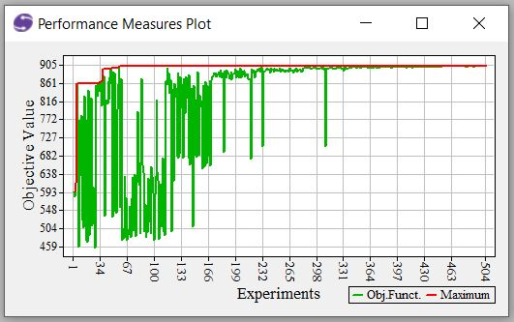 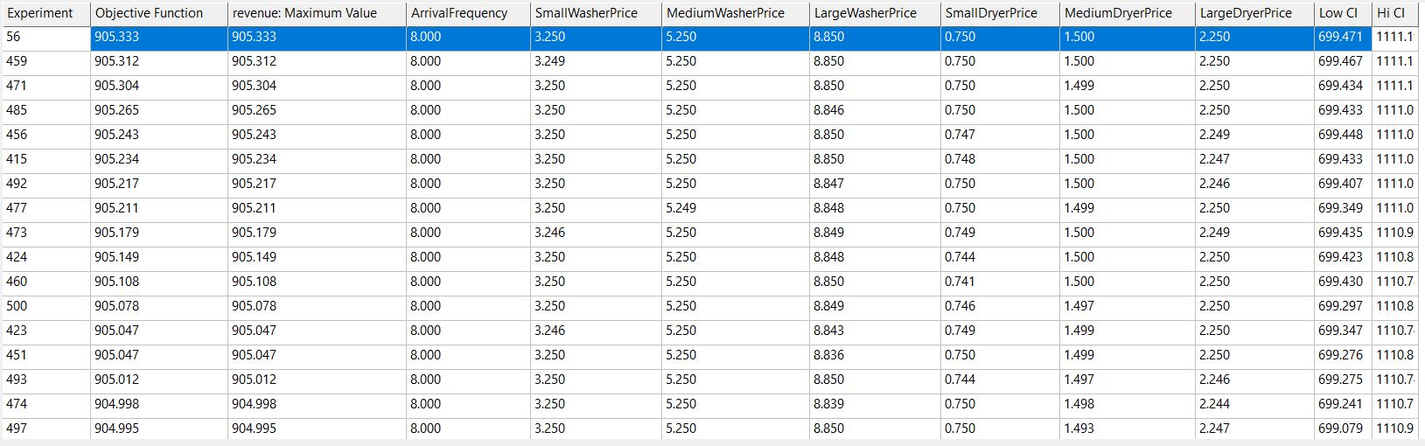

Figures 3 (top) and 4 (bottom): Optimization plot and result table for scenario 1.

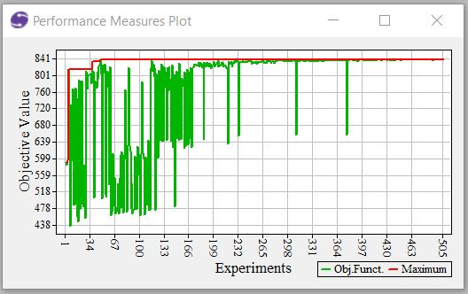

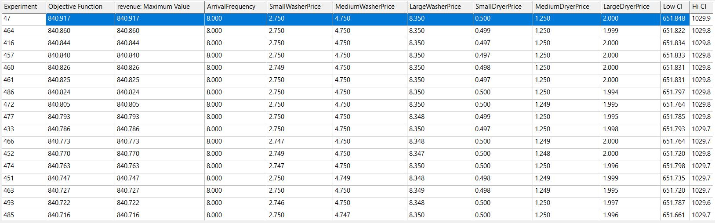

Figures 5 (top) and 6 (bottom): Optimization plot and result table for scenario 2.

As shown by Table 10 and Figures 3-6, assuming a maximum arrival frequency of E(8) minutes, the optimal revenue that can be accumulated is $905.33 in scenario 1 and $840.92 in scenario 2. Even if the arrival frequency doesn’t increase to E(8) minutes, the team’s data shows that the revenues obtained are still extremely likely to exceed the revenues on Monday through Wednesday in Table 8. This is because the gains from the increase in arrival frequency seem to be greater than the losses from the decrease in prices. Therefore, we can conclude from this optimization study that discounting washer and dryer prices on weekdays, with the assumption of a consequent increase in customer traffic, will not only maintain revenues, but potentially increase them.

# RECOMMENDATION

After conducting thorough analysis of the data collected, one significant recommendation that can be made for Platt Laundromat is to introduce a $1 discount on washers and a $0.50 discount on dryers during the weekdays (M-F), creating a “weekday special” for their customers. From our findings, implementing this discount strategy will incentivize more customers to do their laundry on the weekdays as opposed to the weekends. This way, it will make customer traffic for Platt Laundromat more even throughout the week while maintaining and even potentially increasing revenues. The reason the team chose the discounts in scenario 1 of the SimRunner study is that there is a greater chance of a revenue increase even if the arrival frequency doesn’t increase to E(8) minutes. While it is true that a discount may slightly decrease the revenue obtained during the weekends (Sat-Sun), the team believes that the increase in customer traffic during weekdays will outweigh this loss and generate even higher weekly revenue than the current system.

# DISCUSSION

## Conclusion

Using the modeling tool ProModel, we simulated a week of operations at Platt Laundromat using collected data from informal time studies we conducted at the facility. We also utilized SimRunner, ProModel’s built-in optimization software, to identify the best incentives to attract more customers on weekdays, as the facility experiences high volumes on weekends and the owner wanted to find a method to balance customer traffic throughout the week. Using the output data generated by ProModel after running the simulation for each day of a given week, we compared the utilization of different locations, machines, and services within the laundromat, as well as the length of the front desk queue and amount of lost customers.

In this analysis, we did not find overutilization of any of the washers or dryers, on any day of the week. According to the output data, the maximum value of washer utilization (%) was 44.36% on average from Monday to Wednesday, and the maximum value of dryer utilization (%) was 54.87% on average. On the other hand, from Thursday to Sunday, the maximum value of washer utilization (%) was average 58.15%, and the maximum value of dryer utilization (%) was average 68.89%. We also found that very few customers were lost from the threshold of excessive waiting time (>10 minutes) in the waiting area.

In addition, the overall revenue for the week was $6543.95, with Sunday’s revenue contributing $1445.64, more than double the earnings of Monday, Tuesday, and Wednesday. Since our aim was to ensure that customer traffic is distributed throughout the week and reduce the customer wait time, we ran an optimization test on two different discount scenarios for customers on weekdays. We chose an option to offer discounts offering $1 discounts on washers and $0.50 discounts on dryers on weekdays. We hope that this will incentivize more customers to do their laundry throughout the week rather than on weekends, while simultaneously maintaining and possibly increasing weekly revenue of the laundromat.

* 1. **Future Exploration**

There were many unexplored areas of this project involving Platt Laundromat that the team felt should be explored should the opportunity arise in the future. For starters, conducting a longer time study would provide more realistic data due to the increased accuracy of interarrival times. This, in turn, would create more variables to work with that one would normally see at a laundromat which were not included in this project.

Secondly, assumptions were made regarding the general pricing of the services regardless of their function (washer, dryers, etc.). In future models, we would like to have correct pricing inputs or utilize some form of a price distribution to be able to simulate more accurate revenue numbers so that our recommendations to Platt Laundromat can be further strengthened.

Lastly, this project did not focus much on the waiting area specifications. For future modeling cases, studying and gathering data on the waiting room utilization rate would help us in further recommending uses of the space itself to Platt Laundromat. Adding this element would also give us more insight on how to optimize the overall laundromat experience for the customer and generate the maximum amount of revenue possible.

**STUDENT BIOGRAPHIES**

**NIGEL FAULKENS** is a junior studying Industrial and Operations Engineering at the University of Michigan. He is interested in ergonomics and occupational safety in the automobile industry.

**JUHYUN LEE** is a senior studying Industrial and Operations Engineering and minoring in Electrical Engineering at University of Michigan. She is interested in financial analytics, which identifies opportunities or evaluates outcomes for business decisions or investment recommendations.

**NEELAY PATEL** is a master’s student studying Industrial and Operations Engineering at the University of Michigan. Due to his undergraduate background in Biomedical Engineering, he is interested in healthcare, the intersection between business and technology, and entrepreneurship.

**SHAYAAN SIDDIQUI** is a 5th year senior studying Industrial and Operations Engineering with a Minor in Energy Science and Policy at the University of Michigan. He is interested in developing creative and innovative solutions for clients emphasizing environmentally friendly practices.